**COMP301 SOFTWARE DESIGN**

**GROUP PROJECT**

**WEEK 1: 21-28 October 2021**

**WEEK 2: 28 October – 4 November 2021**

**WEEK 3: 4 November 2021 – 11 November 2021**

**KIARA MAHARAJ**

**219008862**

**DEMISHA GOVENDER**

**219014298**

**CHANTAL RONALD**

**218035344**

**REPORT/SUMMARY OF PROGRESS**

**Tasks:**

**(October 21, 2021):**

1. Created React Native App with Expo and Visual Studio Code

*expo init fitlife-app*

1. Installed Firebase

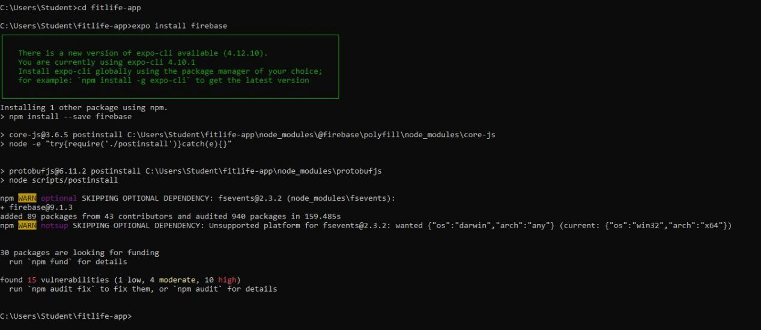

1. Created a project on Firebase console
   1. Registered *fitlife-app* to firebase
   2. Downloaded *google-services.json* file (project configuration)
   3. Retrieved configuration details for *fitlife-app -* api key, app id, sender id, project id etc.

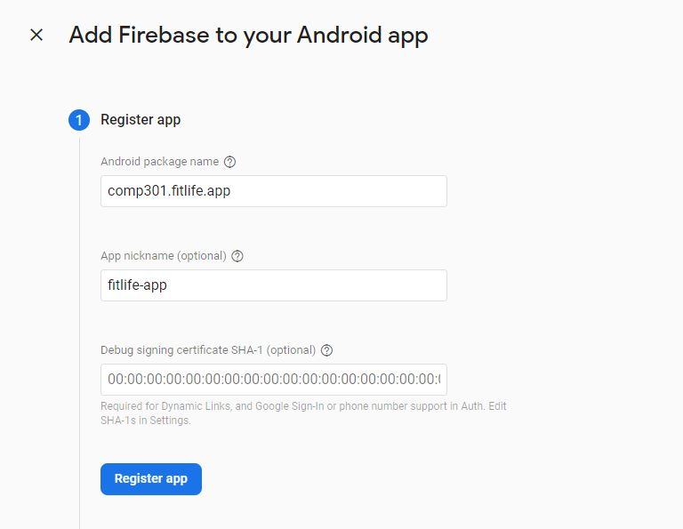

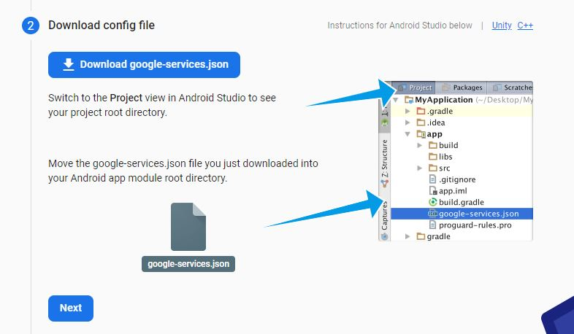

<https://console.firebase.google.com/u/0/project/fitlife-app-7dcc5/settings/general/android:comp301.fitlife.app>

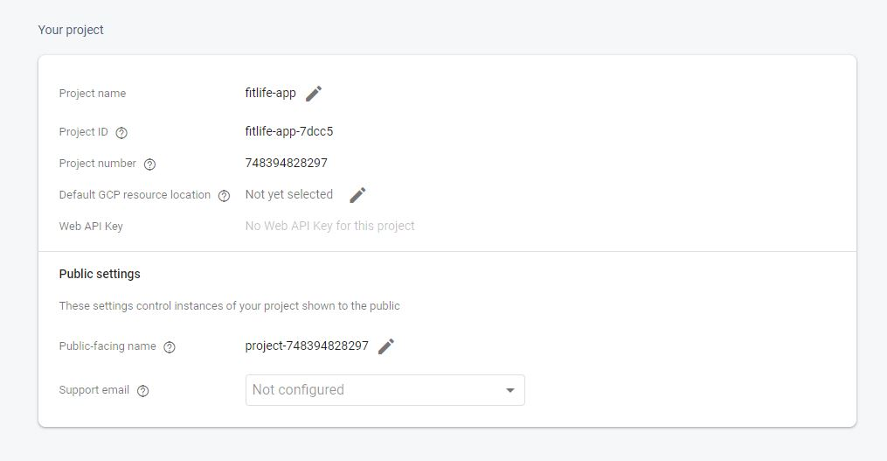

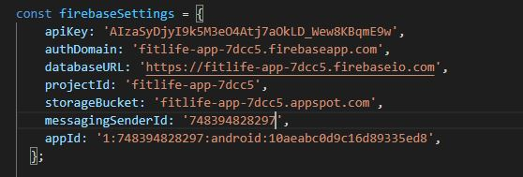

**(October 22, 2021)**

1. Created Components:
   1. Button - *Button.jsx*

*-* variants used across app

* 1. Divider - *Divider.jsx*

*-* used to separate components on a screen

* 1. Icon - *Icon.jsx*

*-* imports and uses react icons (https://react-icons.github.io/react-icons/)

* 1. Input - *Input.jsx*

- component to receive input from user

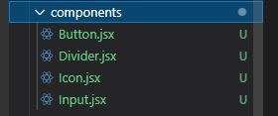

**(October 23, 2021)**

1. Created Layouts:
   1. Sign in - SigInLayout.jsx

**(October 26, 2021)**

1. Created Sign In page

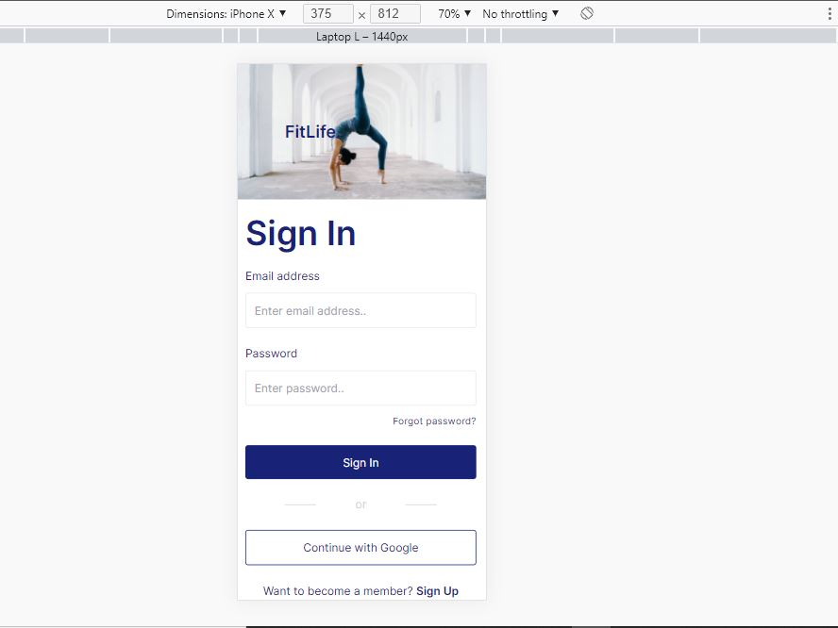

**(October 27, 2021)**

1. Created Hooks:
   1. *useTimer.js*
   2. *useWorkoutDb.js*

**(October 28, 2021)**

1. Uploaded project to my github profile for Demisha to download and work on
2. Group meeting to discuss progress

**(October 28,2021)**

1. Downloaded project that Kiara uploaded to github to work on.

**(October 29,2021)**

1. Created Component for selection of exercise named - SelectExercise.jsx

**(October 30,2021)**

1. Created the next components named WorkoutChart.jsx

**(October 31,2021)**

1. Created the next component named WorkoutScheme.jsx
2. Started with the workout timer named WorkoutTimer.jsx

**(November 1,2021)**

1. Completed WorkoutTimer.jsx and fixed the errors encountered.
2. Started the dashboard layout named DashboardLayout.jsx

**(November 2,2021)**

1. Completed the Dashboard layout
2. Began working on the page for the Dashboard named Dashboard.jsx.

**(November 3,2021)**

1. Completed the dashboard page and did the workout page named Workout.jsx

**(November 4,2021)**

1. Tasks completed, summary of tasks I had to do :

20.1 Components- SelectExercise.jsx, WorkoutChart.jsx,

WorkoutScheme.jsx, WorkoutTimer.jsx

* 1. Layout- DashboardLayout.jsx

20.3 Pages - Dashboard.jsx, Workout.jsx

21. Uploaded the project to my github profile for Chantal to download and work on

22. Group meeting to discuss progress

**(November 5, 2021)**

1. Downloaded project from Demisha’s github to work on

**(November 6, 2021)**

1. Created the components named CalorieChart.jsx and Modal.jsx

**(November 7, 2021)**

1. Created the components Logo.jsx and NavBar.jsx

**(November 8, 2021)**

1. Created the constants file named index.js

**(November 9, 2021)**

1. Created the authorisation context file named AuthContext.jsx

**(November 10, 2021)**

1. Created the workout context files named WorkoutContext.js and WorkoutReducer.js

**(November 11, 2021)**

1. Completed all tasks.
2. Summary:

* Components:
* CalorieChart.jsx
* Modal.jsx
* Logo.jsx
* NavBar.jsx
* Constants
* Index.js
* Contexts
* Auth
* AuthContext.jsx
* Workout
* WorkoutContext.js
* WorkoutReducer.js

**References:**

1. What are react hooks? <https://reactjs.org/docs/hooks-intro.html>
2. <https://blog.logrocket.com/create-a-fitness-tracker-with-react-and-firebase/>
3. Using firebase in expo - <https://docs.expo.dev/guides/using-firebase/>
4. Learn about API keys in firebase: <https://firebase.google.com/docs/projects/api-keys>
5. React icons guide: <https://react-icons.github.io/react-icons/>

**END.**